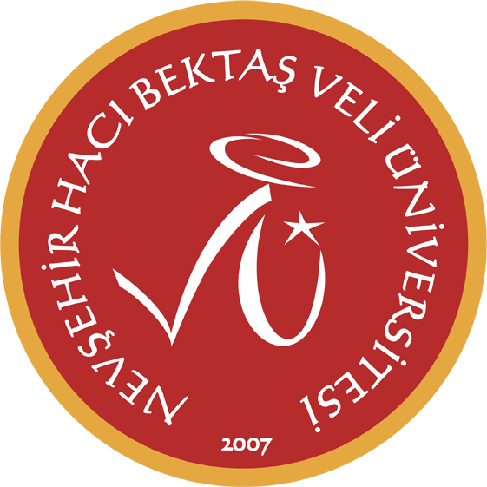
2025 - 2026 Güz Dönemi
Özge Sırma

 | Pazartesi | Sali | Carsamba |  | Persembe | Cuma
08:30 09:15
09:30 10:15 | MC - ENGLISH PREPARATORY (SPC D)  YDYO 4 | MC - ENGLISH PREPARATORY (SPC D)  YDYO 4 |  | MC - ENGLISH PREPARATORY (IR B)  YDYO 9 | MC - ENGLISH PREPARATORY (IR B)  YDYO 9
10:30 11:15 | MC - ENGLISH PREPARATORY (SPC D)  YDYO 4 | MC - ENGLISH PREPARATORY (SPC D)  YDYO 4 |  | MC - ENGLISH PREPARATORY (IR B)  YDYO 9 | MC - ENGLISH PREPARATORY (IR B)  YDYO 9
11:30 12:15 | MC - ENGLISH PREPARATORY (SPC D)  YDYO 4 | MC - ENGLISH PREPARATORY (SPC D)  YDYO 4 |  | MC - ENGLISH PREPARATORY (IR B)  YDYO 9 | MC - ENGLISH PREPARATORY (IR B)  YDYO 9
12:30 13:30
13:30 14:15 | MC - ENGLISH PREPARATORY (IR B)  YDYO 9 | MC - ENGLISH PREPARATORY (IR B)  YDYO 9 |  |  | MC - ENGLISH PREPARATORY (SPC D)  YDYO 4
14:30 15:15 | MC - ENGLISH PREPARATORY (IR B)  YDYO 9 | MC - ENGLISH PREPARATORY (IR B)  YDYO 9 |  | CA- ENGLISH PREPARATORY (SPC F)  H2 | MC - ENGLISH PREPARATORY (SPC D)  YDYO 4
15:30 16:15 |  |  |  | CA- ENGLISH PREPARATORY (SPC F)  H2
16:30 17:15
17:30 18:15

